***Provisioners in Terraform***

In Terraform, **provisioners** are used to execute scripts or commands on a local or remote machine during resource creation or destruction. For Azure, provisioners are commonly used for tasks such as configuring a virtual machine or running initialization scripts after deployment.

**Types of Provisioners in Terraform**

1. **local-exec Provisioner**
   * Executes a command or script locally (on the machine where Terraform is running).
   * Useful for tasks like running CLI commands, invoking scripts, or triggering external processes.
2. **remote-exec Provisioner**
   * Executes commands or scripts on a remote machine (like an Azure VM) over an SSH or WinRM connection.
   * Useful for configuring VMs post-deployment, like installing software or setting up services.

**1. local-exec Provisioner**

**Syntax**

resource "azurerm_virtual_machine" "example" {

name = "example-vm"

location = azurerm_resource_group.example.location

resource_group_name = azurerm_resource_group.example.name

...

provisioner "local-exec" {

command = "echo ${self.name} has been created!"

}

}

**Use Case Examples**

* Trigger a deployment pipeline after creating a resource.
* Notify a monitoring system about resource creation.
* Execute Azure CLI or PowerShell commands locally.

**Advanced Example**

Using local-exec to run an Azure CLI command:

provisioner "local-exec" {

command = "az vm show --name ${self.name} --resource-group ${self.resource_group_name} --output json"

}

**2. remote-exec Provisioner**

**Syntax**

resource "azurerm_virtual_machine" "example" {

name = "example-vm"

location = azurerm_resource_group.example.location

resource_group_name = azurerm_resource_group.example.name

connection {

type = "ssh"

host = azurerm_public_ip.example.ip_address

user = "azureuser"

private_key = file("~/.ssh/id_rsa")

}

provisioner "remote-exec" {

inline = [

"sudo apt-get update",

"sudo apt-get install -y nginx"

]

}

}

**Use Case Examples**

* Installing software on a VM (e.g., Nginx, MySQL, or Docker).
* Running configuration management tools (e.g., Ansible or Puppet).
* Setting up environment-specific configurations.

**Connection Block**

The **connection block** specifies how Terraform connects to the remote machine:

* **type**: Connection type (ssh or winrm).
* **host**: The public or private IP address of the VM.
* **user**: The username for the remote machine.
* **private_key**: The private key file for SSH authentication.
* **password**: (Optional) Password for authentication (for WinRM or SSH).

**Inline and Script Options**

* **Inline Commands**: Directly provide commands to execute.
* **Scripts**: Execute a script file.
* provisioner "remote-exec" {
* script = "scripts/setup.sh"
* }

**Key Considerations**

* **Idempotency**: Provisioners should ideally produce the same result if run multiple times.
* **Error Handling**: Provisioners can fail, causing resource deployment to fail. To prevent this:
* provisioner "remote-exec" {
* when = "create"
* }

Use when = "create" or when = "destroy" to control when provisioners run.

* **Secure Authentication**:
  + Use SSH keys for Linux VMs.
  + Use managed identities or securely store credentials for Windows VMs.
* **Alternative Approaches**:
  + Use Terraform for infrastructure provisioning and tools like Ansible for post-deployment configuration.
  + Use Azure-specific services like **Custom Script Extensions** or **Cloud-Init** for VM initialization instead of provisioners.

By using **remote-exec** and **local-exec** provisioners, you can automate and customize the initialization process for Azure resources effectively.

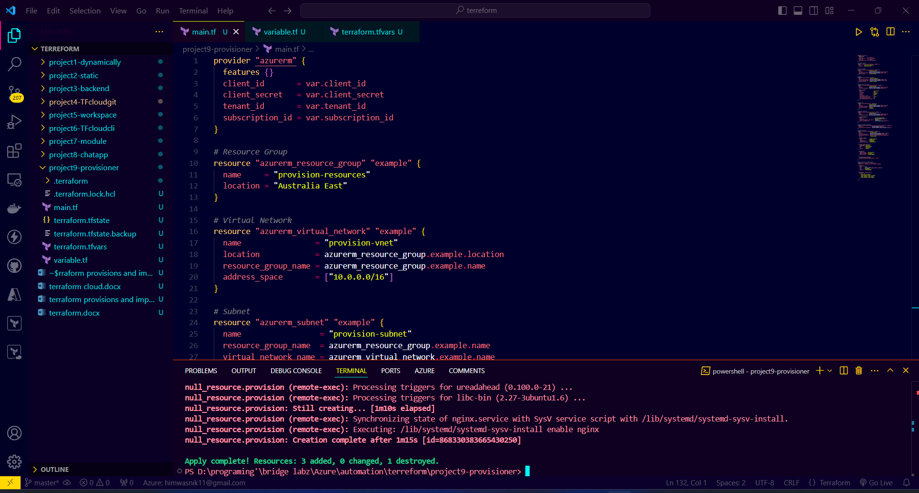

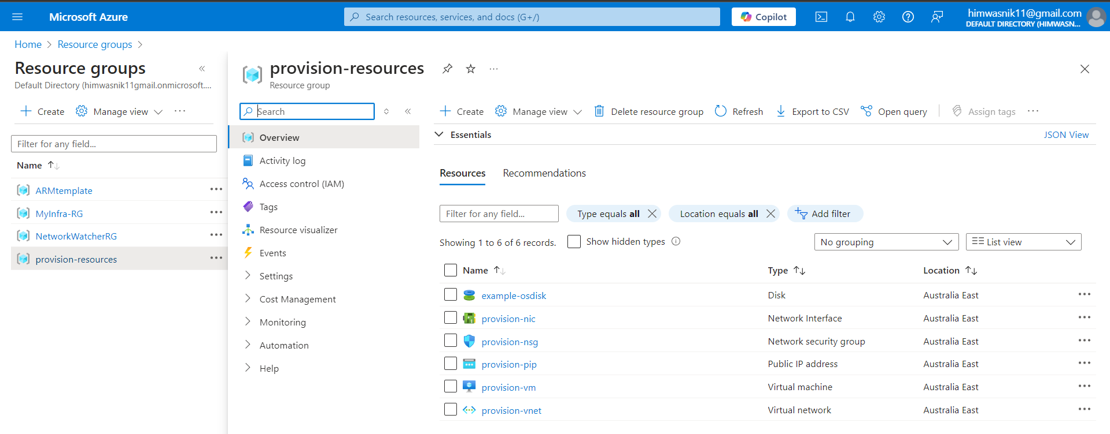

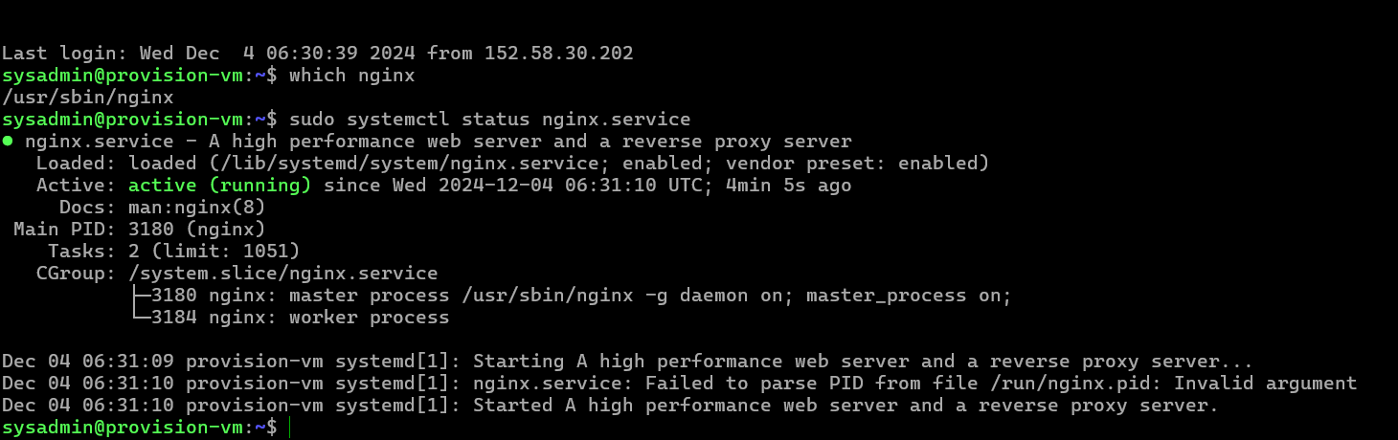

***Import Terraform configuration***

Ex If you create a Virtual Machine (VM) manually in the Azure Portal, import it into Terraform, and then run terraform plan, the message **"No changes. Infrastructure is up-to-date"** confirms that:

1. **The VM is successfully imported into the Terraform state file.**
2. **The Terraform configuration in your .tf file matches the actual resource's current state in Azure.**

This means Terraform is now managing the resource without needing to make any changes, which is the expected behavior after a successful import.

**Steps Recap for Your Scenario**

1. **Create a VM Manually in Azure Portal:**
   * Go to the Azure Portal.
   * Create a Virtual Machine with your desired configuration (e.g., VM size, OS, resource group, network settings, etc.).
2. **Gather VM Details:**
   * Use the Azure CLI or the Azure Portal to fetch details like:
     + Resource Group Name.
     + VM Name.
     + Subscription ID.
3. **Write Terraform Configuration:**
   * Create a main.tf file in VS Code with the Terraform configuration for the manually created VM.
   * Ensure the configuration matches the existing resource's details.
4. **Import the VM into Terraform State:**
   * Run the import command in VS Code terminal:
5. terraform import azurerm_virtual_machine.example /subscriptions/f78b1160-ac53-46e6-b77c-be73847ecb68/resourceGroups/ARMtemplate/providers/Microsoft.Compute/virtualMachines/test
6. **Check the State:**
   * Verify the imported resource using:
   * terraform state show azurerm_virtual_machine.example
7. **Run Terraform Plan:**
   * Execute:
   * terraform plan
   * If the output says **"No changes. Infrastructure is up-to-date,"** it means the import was successful.

**Why "No Changes" Confirms Success?**

* **Terraform State Matches Configuration:** The state file now accurately reflects the actual VM in Azure, and the Terraform configuration aligns perfectly.
* **No Drift:** Terraform did not detect any discrepancies between the configuration and the actual resource.
* **Terraform Management:** The resource is now managed by Terraform, so any future changes to the configuration will be applied using Terraform commands.

**What’s Next?**

To deepen your skills:

1. **Modify the Configuration:**
   * Add or update attributes like tags or VM size in your main.tf.
   * Run terraform plan and terraform apply to see the changes take effect.
2. **Practice Importing Related Resources:**
   * Import associated resources like network interfaces, disks, or public IPs.
   * Write Terraform configurations for these resources.
3. **Set Up a Remote Backend:**
   * Use an Azure Storage Account to securely manage your Terraform state file.

This workflow will help you get comfortable with Terraform's import and state management features while working with Azure resources!

